NATIONAL PUBLIC SCHOOL, BANGALORE
Presentation of Class Activity by students of Grade VIII
… A report
THEME: Moral Values DATE: 29th Sept 2015
TOPIC: Change your thought about yourself and see your sense of learning
spirals.
- Obedience
- Seek Parent’s help
- Self-worth
- Obstacle is a new opportunity to learn.
Students of Grade VIII ‘A’ and ‘B’ took an initiative to inculcate and imbibe moral values among themselves and others through 4 skits. A powerpoint presentation was prepared by the students to support the setting of the skit.
Skit -1 – Obedience greatest gift of god.
Obedience, is one of the highest value in humans. Obedience is generally distinguished from compliance, which is behaviour influenced by peers, and from conformity, which is behaviour intended to match that of the majority.

Skit – 2 - Tiny Star
Children are still are too young to decide over things and must seek parent’s guidance.

Skit – 3 – Self – Worth
Our energy, confidence and attitude are the currency that others transact with. To build self-worth, we must first discover our values and build our own definition of success. Self-worth and self-esteem are vital beliefs for empowering oneself.
Skit – 4 – Obstacles turn into opportunity.
Every obstacle is a new opportunity to learn.
The entire class activity concluded with a message – All of us should be inspired to pursue our dreams and learn to discover the impact we are meant to have on the world through a prayer. Principal speaking on the occasion urged the students to practice what they put forth through the skit.
 | 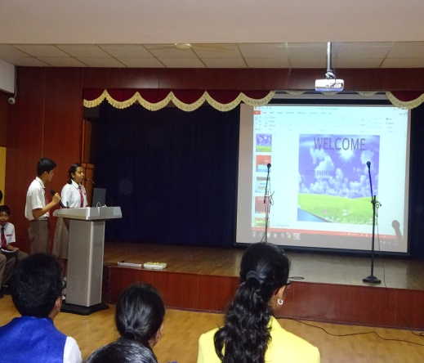 | 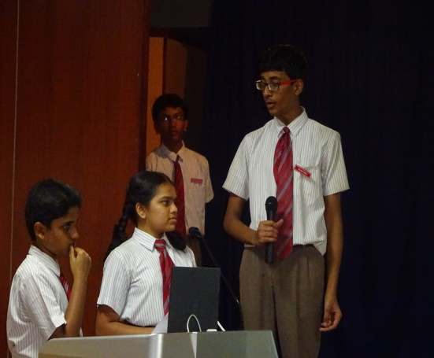
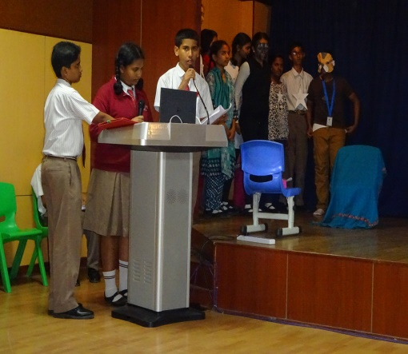 | 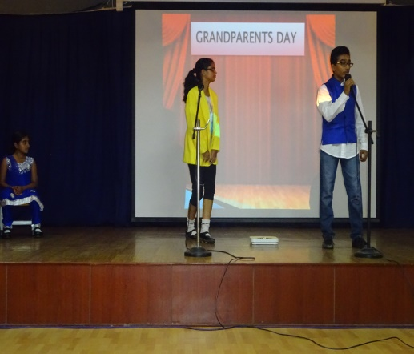 | 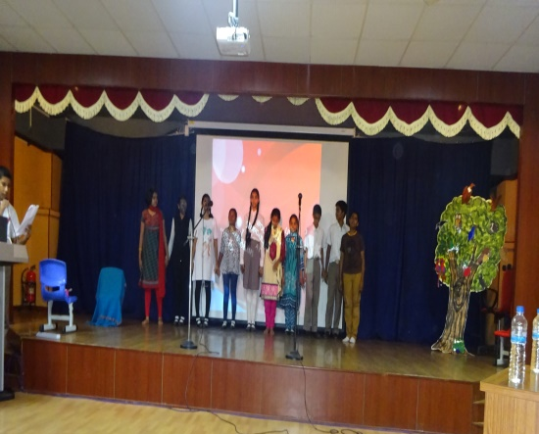
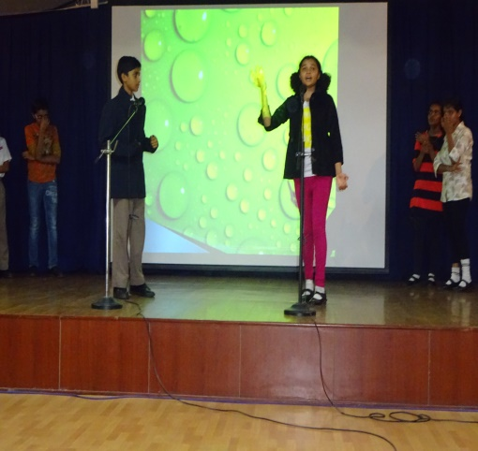 | 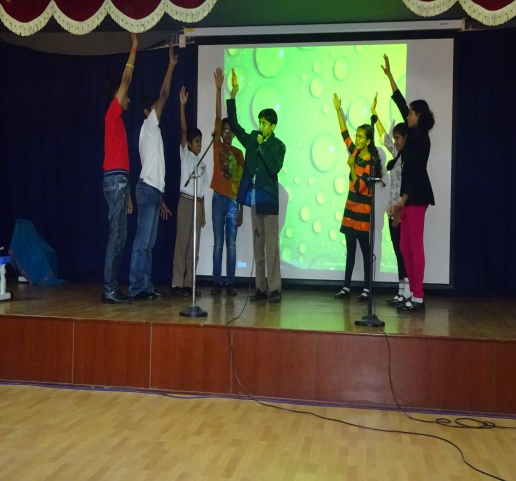 | 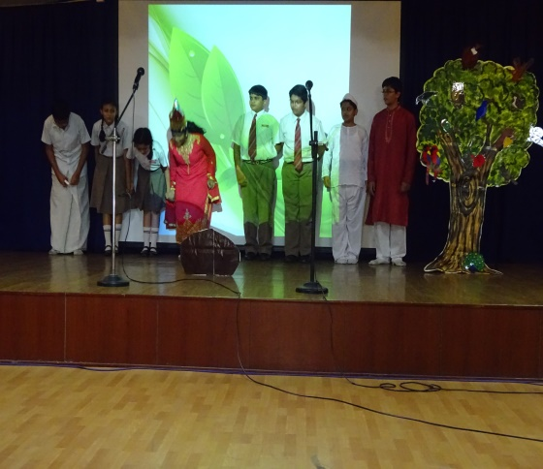
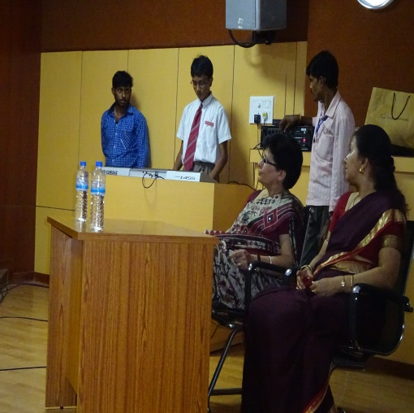 | 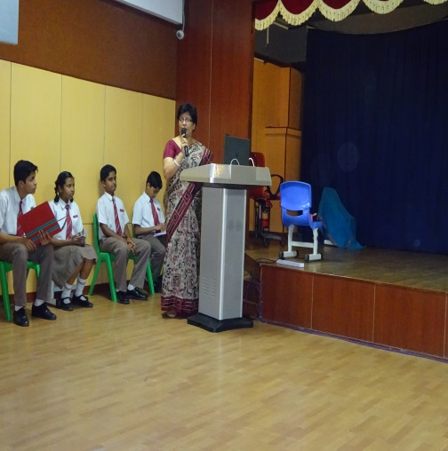 | 